

John McGlashan College

Year 9 Science

END OF YEAR EXAMINATION 2011

Suggested Time: 2 hours

Chemistry / Biology / Physics / Planet Earth and Beyond

Student Name:

Form Class:

 | NOT YET ACHIEVED | ACHIEVED | MERIT | EXCELLENCE
Biology
Physics
Chemistry


Tools of the Lab
Q1. Jason and Mark wanted to make a catapult for firing marbles. They wanted to know whether it was better to use thin rubber bands that could be pulled back a long way, or thicker ones which require more force to pull them.
First of all they took a thin band, pulled it back 3 cm, fired a marble and found it trvelled 36 cm. Then they put 2 thin bands together, pulled the pair back 3 cm and found the marble travelled 54 cm. They repeated this with 3, 4 and 5 bands and got distances of 72 cm, 90 cm, and 108 cm.
a) What did they keep constant? ________________________________________________________ (A)
b) What did they change? (This is the independent variable). _________________________________
___________________________________________________________________________________ (A)
c) What did they measure? (This is the dependent variable) __________________________________
___________________________________________________________________________________ (A)
d) What were they trying to find out? (This is the aim) ______________________________________
___________________________________________________________________________________
___________________________________________________________________________________ (A)
e) Put the boys results in table form:
(M)
f) Write a conclusion based on the results ________________________________________________
__________________________________________________________________________________
__________________________________________________________________________________ (A)
2. Next the boys wanted to find out whether the stretch of the rubber band made any difference.
a) What should be kept constant? ______________________________________________________ (A)
b) What is the independent variable? ___________________________________________________ (A)
c) What is the dependent variable? _____________________________________________________ (A)
d) Draw up a results table for this experiment including the stretch for each band. (M)
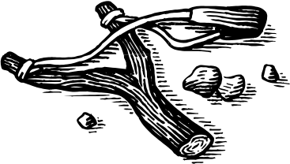

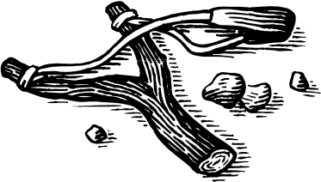
Q2: The diagram below shows some of the laboratory equipment used in a science lab
Match the following names with the correct piece of equipment
Beaker Funnel Gauze Mat Evaporating Dish Test tube Holder
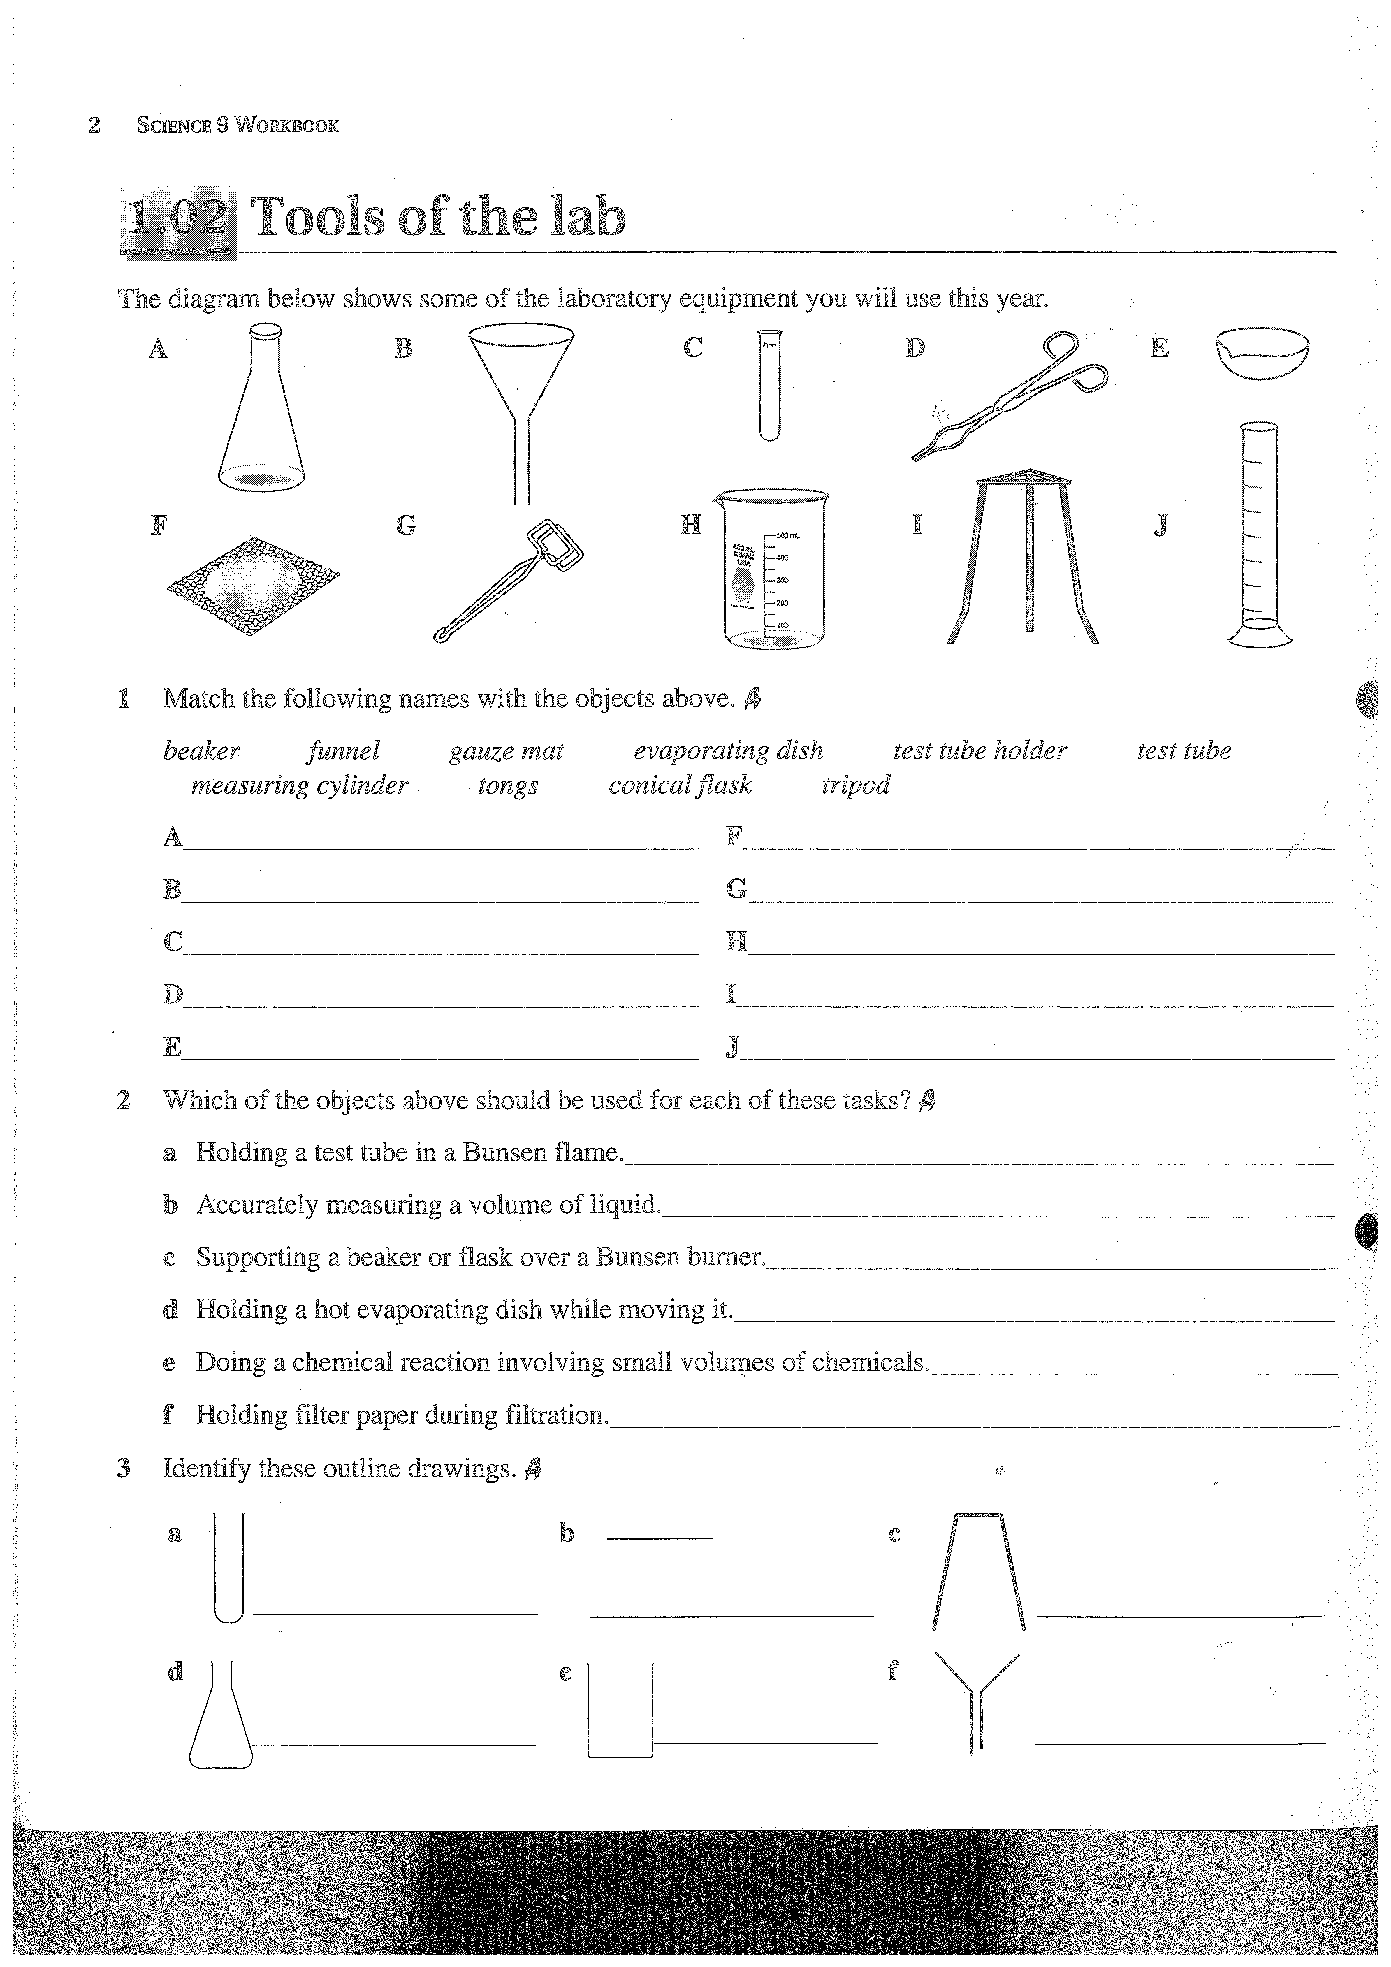
Test Tube Measuring Cylinder Tongs Conical Flask Tripod

A _________________ B ____________________ C _________________
D _________________ E ___________________________________
F _________________ G _____________________________ H ______________
I __________________ J ________________________________ (A)
Science | The study of | Science | The study of
Cardiology | The heart and its diseases. | Paleontology | Fossils
Haematology | blood | Petrology | Rocks
Oncology | Tumors | Seismology | Earthquakes
Osteology | Bones | Toxicology | Poisons
Q3: Words in science are often built up from greek or latin roots. For example, a photo-graph is a picture mage from light. The prefix selen comes from the Greek word for moon, so selenography is the study of the physical features of the moon. A selenologist is a person who studies the moon.

Use the table to help you answer the following questions.
a) Haematite is a mineral. What colour would it be? ______________________________________________
b) What do oncogenic compounds cause? ______________________________________________________
c) What would a seismometer measure? _______________________________________________________
d) What is a toxic substance? _______________________________________________________________
e) A zoologist studies animals. What sort of animals does a paleozoologist study? ______________________
f) A glyph is a symbol or drawing. Where would you find a petroglyph? ____________________________
g) What information would be shown on a cardiogram? _________________________________________
h) What kind of tumor is an osteosarcoma? ___________________________________________________
(A/M)
Q4. Laboratory work often involves reading scales on meters, on measuring cylinders and on other equipment. Read the scales below and record your readings in the spaces provided.
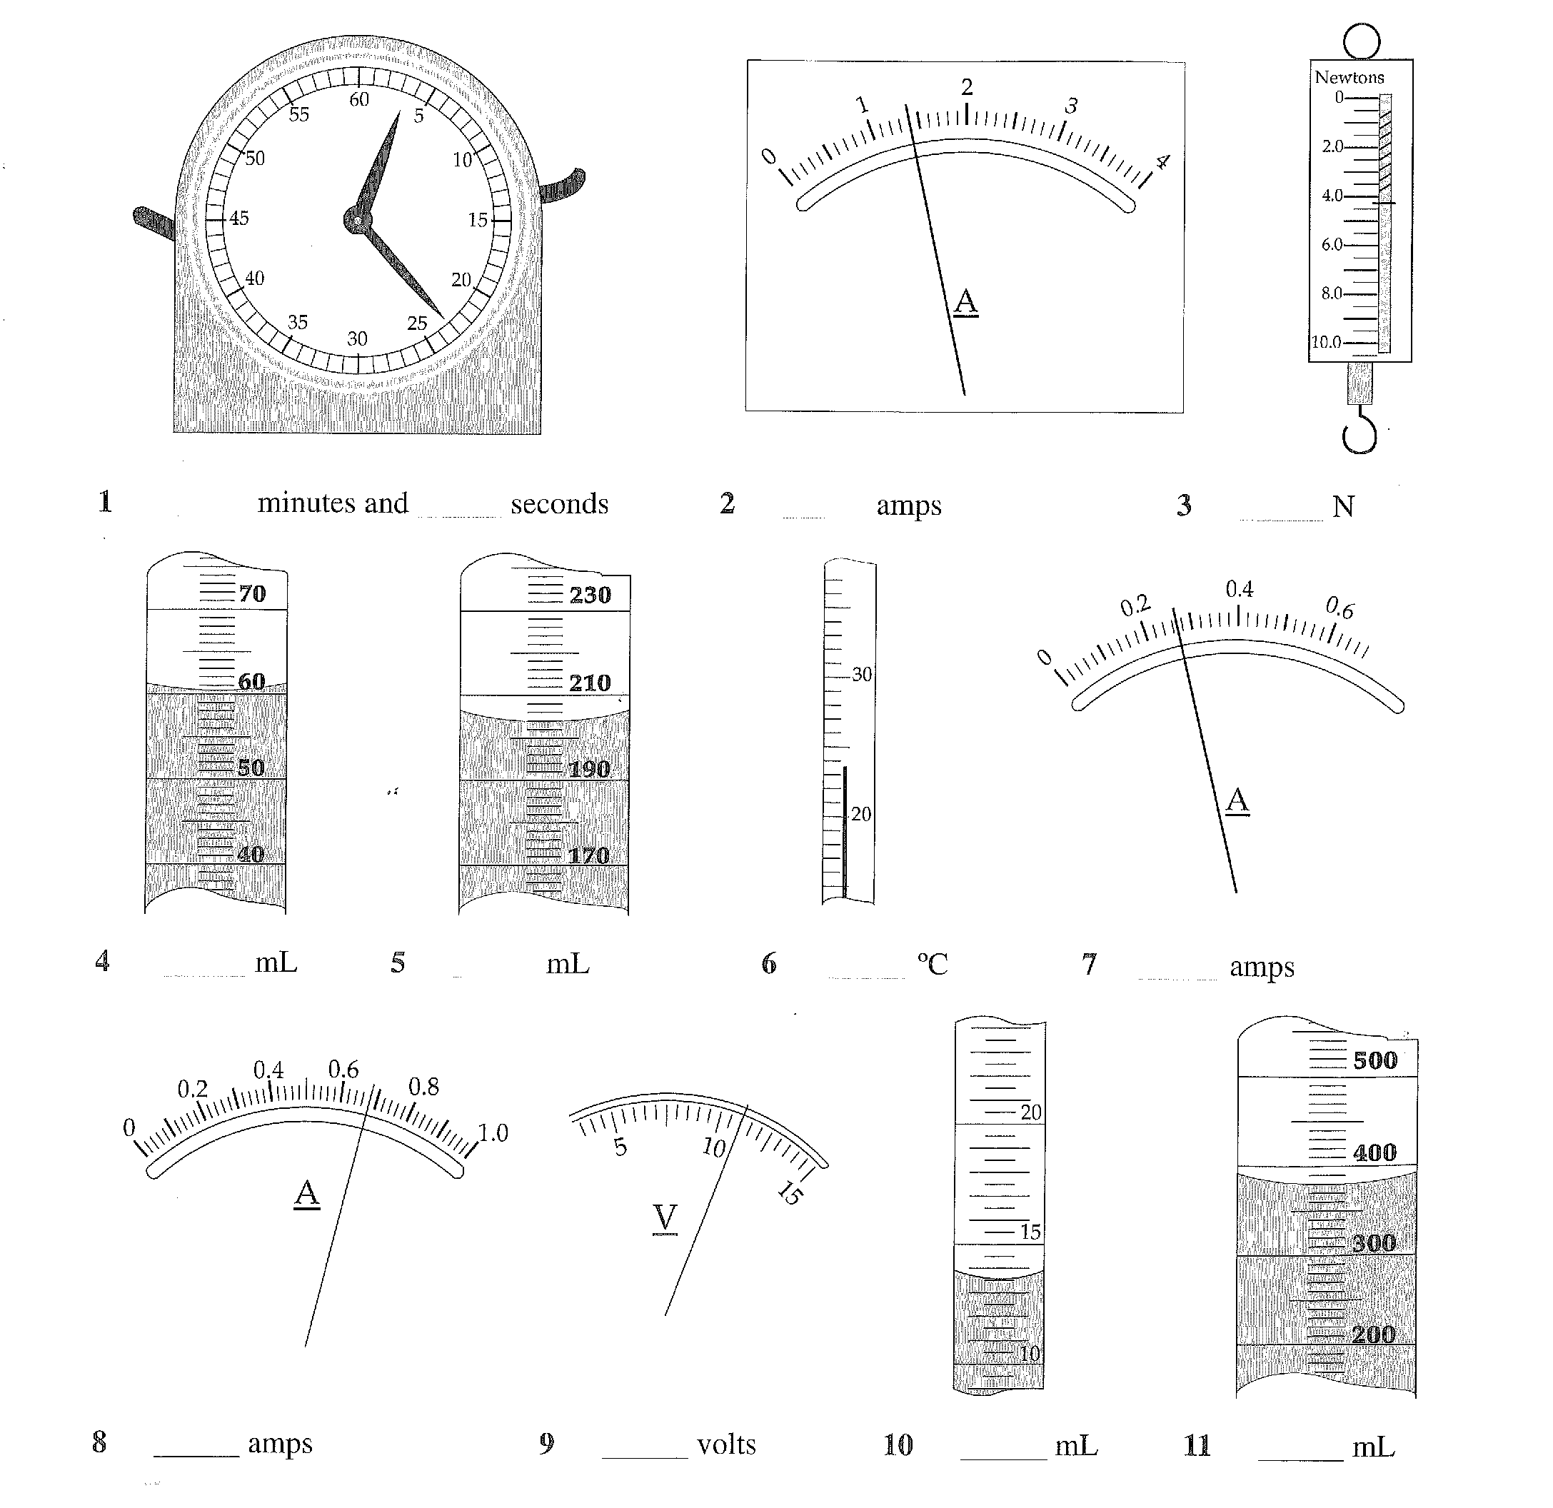

(A/M)
The Living World

Q1. To be considered a living thing, all organisms need to carry out the seven life functions. Make a list of these seven features using the starting letters in the table below.

(a) In the list below fill in the six missing characteristics.

M
R | Respiration
S
G
R
E
N
(A/M)

(b) The function RESPIRATION was done for you. Write a definition for this function.

(M)
c) Write a definition for the function beginning with “E”.

(M/E)
Q2. Ecology can be defined as the study of the relationships between living organisms and their environment. Some of the words which are important in this study are written below as well as their meanings. Match the words and meanings correctly by writing the correct word alongside its meaning.

Word list: habitat environment species population community

Meaning | Word
A category of related organisms that can breed with each other. | (a)
The place where an organism normally lives. | (b)
The physical conditions that affect living organisms. | (c)
A group of plants and animals living and interacting with each other. | (d)
All the organisms of a particular type living in the same area. | (e)
(A/M)
Q3. Read the following paragraph on Archey’s Frog

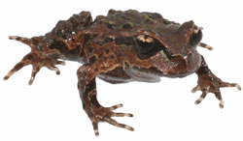
The frog lives on cloud-shrouded misty ridges, away from open water on the North Islands Coromandel peninsula. It hides away under stones and rotting logs during the day, emerging at night to feed on small insects, worms and other invertebrates. Unlike other frogs it has no swimming tadpole stage and no webbing between its toes on its hind feet. In spring the female lays a few large eggs, which the male broods until they hatch. Froglets emerge and clamber onto the males back where they remain for up to three months.

(a) In the description of the Archey’s frog and how it lives there are a number of biotic and abiotic factors mentioned about its environment.

- Identify an abiotic factor.
(A)
(ii) Identify a biotic factor
(A)
(b) Describe one characteristic of the Archey’s frog preferred habitat.

(M)

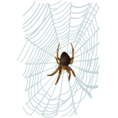

A garden food web
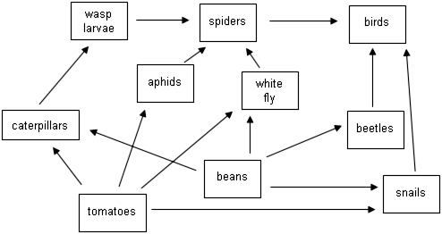
Q4. Food Webs
a) On the food web what do the arrows represent?
(A)
b) Use the food web to complete the Venn diagram below, to show which animals eat beans, which eat tomatoes, and which eat both. The Venn diagram has been started for you, showing that snails eat both tomatoes and beans.

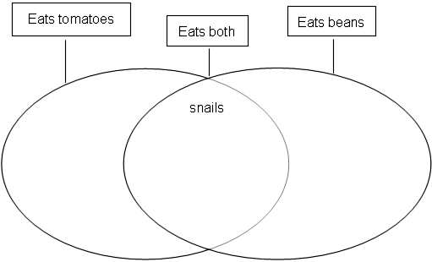(A)

c) The gardener uses a spray that kills aphids and white fly. Choose 3 different animals in the food web and discuss how this will affect them.

1.

2.

3.

(A/M/E)

d) Which animal will probably disappear when all the bean plants are pulled out?

(A)
Why?

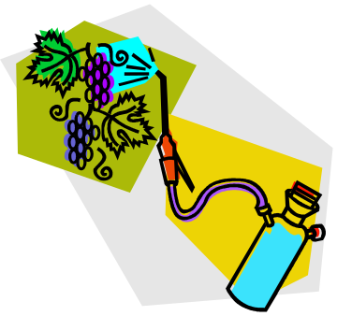
(M)
Q5. Here is some information about feeding links between several different animals and plants.

sparrow |  | hawk
grass |  | caterpillar
rabbit |  | cat
grass |  | rabbit
gorse |  | beetle
caterpillar |  | sparrow
rabbit |  | hawk
beetle |  | sparrow

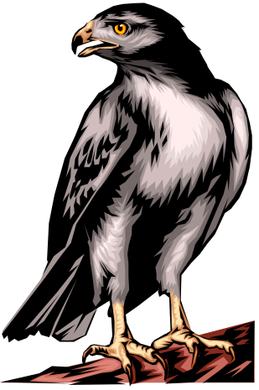
In the box below construct a food web showing all of the feeding links shown above.

(M/E)

I am what I eat.


Q1. The human digestive system is shown below.

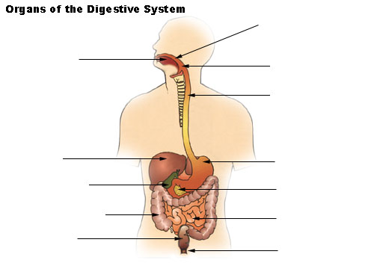
A
B
C
D
E
F
G
H
I
J
K
L

(b) State the names of the following parts of the digestive system.
(i) B
(ii) D
(iii) K
(iv) C
(v) J
(vi) E
(A/M)

Q2. A food company carries out laboratory tests on some of its products. The results are recorded below. Fill in the gaps to complete the report.

Product | Food type being tested | Chemicals added | Positive result
(i)Honey |  | Benedicts solution
(ii)Bread |  |  | Change to a blue-black colour
(iii)Milk |  | Sodium hydroxide and copper sulfate solution (Biuret Solution)

(M/E)
Q3. Explain in detail (discuss) why we need to eat protein.

(M/E)

Q4. If you bought a packet of food labeled “Energy food”, what food type would it probably contain most of?

(A)

Q5. When starch is broken down in the digestive system, what is the name of the small nutrient molecules it makes?

(A)

Q6. Below is the information a milk company puts on the container of each of three different types of milk it produces.

MILK A | MILK B | MILK C
FRESH NON-FAT MILK  NUTRITIONAL INFORMATION | FRESH HOMOGENISED MILK  NUTRITIONAL INFORMATION | FRESH NON-FAT CALCI-  TRIM MILK NUTRITIONAL INFORMATION
Approx. Per 100 mL  Energy 154 kJ  Protein 4.3 g  Fat 0.2 g  Carbohydrate 4.3 g  Calcium 160 mg | Approx. Per 100 mL  Energy 260 kJ  Protein 3.4 g  Fat 3.3 g  Carbohydrate 4.7 g  Calcium 120 mg | Approx. Per 100 mL  Energy 175 kJ  Protein 5.8 g  Fat 0.1 g  Carbohydrate 4.5 g  Calcium 205 mg
INGREDIENTS  Pasteurised non-fat milk,  non-fat milk solids. | INGREDIENTS  Pasteurised standardised  homogenised milk. | INGREDIENTS  Pasteurised non-fat milk,  non-fat milk solids.

a) Which milk would give you the most energy if you drank 200 mL?

(A)
b) Which milk would be the best for someone who is concerned about the strength of their bones?

(A)
c) Explain why this milk would be good for that person.

(A)

d) Which milk would be the best for a woman who is 5 months pregnant?

(A)
e) Explain why you chose this milk.

(M)


Sound and Vision

Q1: The Structure of the eye.

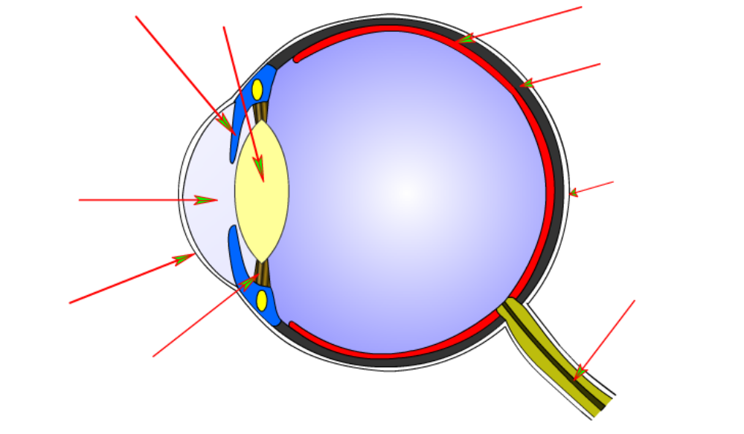
Fill in the table below with the correct names for each part of the eye in the diagram.
a)
b)
f)
g)
h)
i)
c)
d)
e)
a)

b)
c)
d)
e)
f) Sclera
g) Choroid
h)
i)

(A/M/E)

Q2: What is the area of the field of view called, that if light hits it, no image is generated?
a) (A)

What structure of the eye is responsible for answer to 2a?
b)
(M)

Q3. List the colour of the spectrum in order.

Infra Red 1 2 3 4 5 6 7 Ultra Violet
(A)

Q4. This diagram shows a ray of light being reflected off of a mirror. Give names to the labeled angles of the diagram.
c
a
b

a = b = c =
(M)

Q5: What is the equal angle rule in terms of reflection of light.

(A/M)

Q6: What is occurring to the beam of light in each of the following diagrams?
a = b = c =
(A/M)

Q7: Complete the following ray diagram by adding the path of the reflected rays. (use a ruler)

(A/M)

Q8: Complete the following ray diagram by adding the path of the rays that. Pass through the lens (use a ruler)

(A/M)

Q9: What are three ways lenses are used in every day life?
a:
b:
c:

(A)

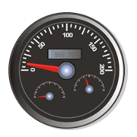
I’m on the move!
Q1: Complete the following sentence.
A force can be a _____________ or a ______________. The unit for force is the _______________, which has the symbol ______ . A force can change an objects __________, __________ or ___________________, or a combination of all three.
(A/M)
Q2: Based on the statements you have made in question 1, write a few sentences that justify the statement “friction is a force”.

(M/E)

Q3: The following table has data missing. Using the information it already contains and your understanding of the difference between mass and weight, complete the table. The first one has been done for you. Don’t forget the units for the column headings.

Object | Mass ( ____ ) | Weight ( ___ )
Shoe | 0.25 | 2.5
Cat |  | 12
Person |  | 650
Car | 1200
Spoon | .025

(A/M)
Q4: What type of energy do the following objects mainly possess?
- A stick of dynamite
- A flying plane
- A person about to bungee jump
- A stretched bungee cord
- An echo
- A camp fire
(A)
Q5: Complete the following sentences.
When your car is moving it has _______________ energy. This energy comes from the burning of petrol in the motor. The petrol contains stored ________________ energy. This petrol was refined from oil. The chemicals in oil were originally produced by microscopic plants that lived in the sea. These plants obtained their energy from ___________ energy coming from the sun.
(A/M)
Q6: If the average speed of an object can be calculated using the formula:
speed = distance/time
Calculate the average speed of the following in meters per second (ms⁻¹)
- A snail takes 20 minutes to cover 4 meters. (2 decimal places only)

(A/M)
- A student runs the 3000 meter race in 8.5 minutes.

(A/M)
Q7: If a motorcyclist in the Moto GP is traveling at 300 km hr⁻¹, how fast is he going in meters per second. (show all workings).

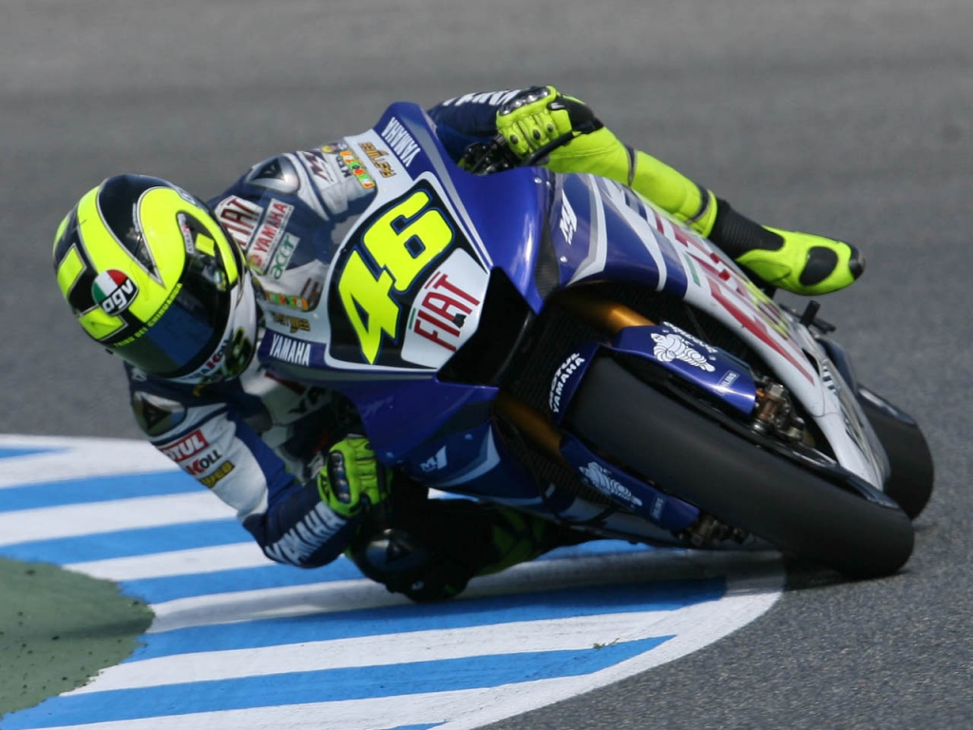
(A/M/E)
Graphing and Interpretation Skills
The table below gives the temperatures recorded at different depths (as a change from the surface temperature) in a section of the Earth's crust.
  - plot this data as a line graph.

Depth (km) | 0 | 1 | 2 | 3 | 4 | 5 | 6 | 7 | 8
Temperature (°C) | 0 | 20 | 45 | 70 | 95 | 120 | ? | 170 | 195

Temperature change with depth in the Earth's crust


Depth (km)

(A/M/E)

  - From the graph, what is the temperature at a depth of 6 km? __________ °C (A)
c) An underground coal mine is being developed in this area. If the miners could work in temperatures of 30°C or less, what is the maximum depth this coal mine could be?
__________ km (M)
d) Calculate the average temperature change for each kilometer change in depth. __________ °C

(M)
e) Explain what the relationship is between the change in temperature and the change in depth.

(M/E)
MY CHEMICAL WORLD

Q1. The following three diagrams show a substance in three states. Which diagram represents the:
(a) Liquid state
(b) Solid state
(c) Gas state
A
B
C

(A)

Q2. The diagram below represents the changes of states of matter between the solid, liquid and gas phases. Label each of the arrows with the word that best describes what is occurring for one state to become another.

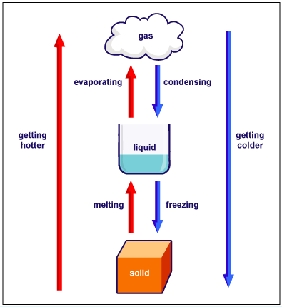

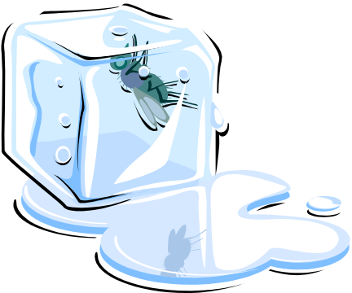

(A/M)
Q3. Complete the following statement using the supplied key words.

DISSOLVED SOLVENT SOLUTE

SOLUTION MIXTURE

John was feeling rather thirsty after mowing the lawns. He went into the kitchen to make himself an orange drink. He used cordial concentrate powder to make the drink. He put a tablespoon of cordial into a glass of water and stirred until all the powder had ________________. From a scientific perspective the orange juice powder was the _______________. It was dissolved by the water which acted as the _______________. Together they made a _________________ composed of a ______________ of water and the orange juice concentrate. (A)

Q4. Discuss how you could prove that a chemical reaction had not taken place but the orange juice had only dissolved in the water.

(M/E)

Q5. Study the table and answer the associated questions on the boiling point of fuels called alkanes.

Alkane Fuel | Boiling Point (ºC)
Butane  Ethane  Heptane  Hexane  Methane  Octane  Pentane  Propane |   -1  -89  98  69  -162  126  36  -42

- Which alkane has the lowest boiling point? (A)

b) Which alkane has the highest boiling point? (A)
c) Put the alkanes in order from the lowest boiling point to the highest.
1.

2.
3.
4.
5.
6
7.
8. (A)

- If room temperature is 20 ºC complete the table below by putting the alkanes in the correct column.

Alkanes liquid at room temperature | Alkanes gases at room temperature

(M)


Gas Tests

Q6: In the space below draw a labeled diagram to show how you would react hydrochloric acid with magnesium ribbon, collect the produced gas and test the gas to identify it.

(M/E)
Q7: What was the gas produced by this reaction and how does the experiment show you this?

(M)

Experimental Design Skills

Q8: You have been given a mixture of sand, iron filings and salt in a beaker. Your task is to separate these three substances. Write a stepwise method showing how you will achieve this. You can use labeled diagrams as well as text.



(A/M/E)

