John McGlashan College

Year 9 Science
END OF YEAR EXAMINATION 2013

Time: 2 hours

Student Name:

Form Class:

 | NOT ACHIEVED | ACHIEVED | MERIT | EXCELLENCE
Skills & I’m a Scientist
Living world
I am what I eat
Light & Sound
On the Move
My Chemical World
GPA

Science Skills
Name: _________________________ Form Class: ______

Question 1a
(a) Write the name of the apparatus under its picture.
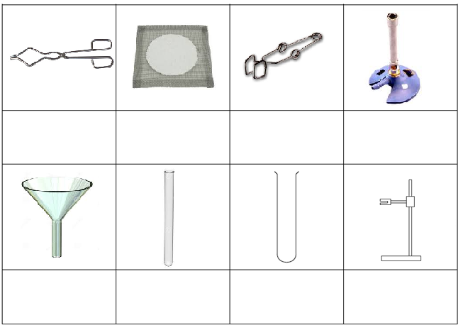A/M
Question 1b

Give the FULL function of the following pieces of lab equipment

Test tube rack
Thermometer
Tripod
Measuring cylinder
A/M

Q2 Reading equipment
On some scales the markings are not placed at equal intervals. Often, the gap between them gets smaller and smaller. The two radio station frequency scales below are both like this.
530 600 700 800 1000 1300 1600

Kilohertz
SportsAM
a) AM radio stations have frequencies measured in kilohertz and these are often shown on a scale like the one above.
RadioRock
i) What is the frequency of radio station
SportsAM? __________ kilohertz

RadioRock? __________ kilohertz

ii) Draw an arrow labelled Kidz at 1350 kilohertz on the scale above.
- Exposure to radiation is measured in milliRoentgens per hour (mR/h)
- What radiation exposure level is indicated by
arrow A? __________ mR/h
arrow B? __________ mR/h
ii) Draw an arrow labelled C at 35 mR/h on the scale above. A/M
- Explain why it might be necessary to have scales such as these that don’t have even increases on their scales.

A/M

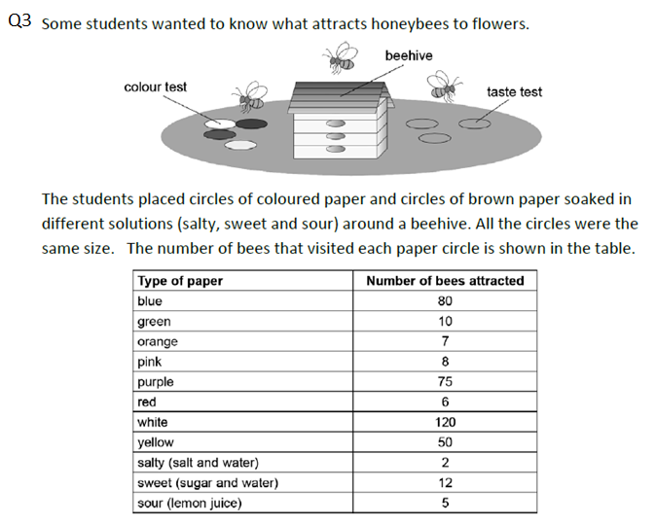
A/M
A
(iv) Explain the reasons why you chose the answer you did in question (iii)

A/M
(v)Explain what this experiment tells you about the sense of vision, smell and taste in bees in relation to flower preference.

A/M/E
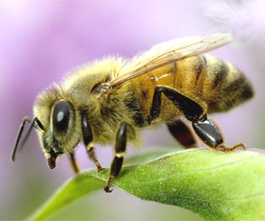
Q4 Toy car experiment
Simon and his cousin were playing with his cousin’s toy cars by rolling them down a ramp and watching them come to a stop. Simon began to wonder if the mass of the toy car affected the stopping distance. He decided to carry out a fair test experiment to investigate the idea.

Q4a Fill in the following sections of an experimental plan below to show how he should set up his experiment .
Aim:

Hypothesis:

Equipment:

Independent variable:

Dependent variable:

Controlled variables:

A/M/E
Q4b Describe one other thing that Simon could do to make sure that this is a valid and reliable experiment. Explain why he should do this.
A/M
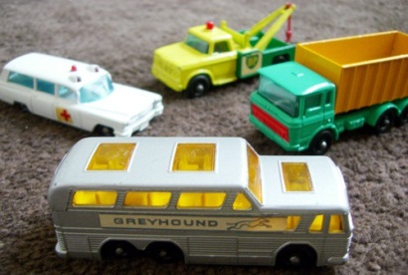

The Living World
Name: _________________________ Form Class: ______

Question 1 To be considered a living thing, all organisms need to carry out the seven life functions. Make a list of these seven features using the starting letters in the table below.

(a) In the list below fill in the six missing characteristics.

M | Movement
R | Respiration
S
G
R
E
N
(A/M)

(b) The function MOVEMENT was done for you. Define this and explain the need for it.

(A/M)
(c) Discuss why it is necessary for organisms to carry out the life process of Respiration.

(A/M/E)
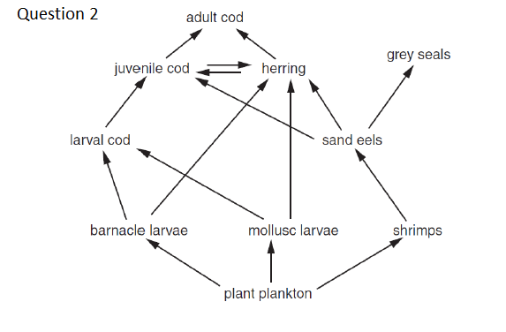
2a) Write down one FULL food chain involving the shrimp

A/M
2b) Complete the table to show one example of each of stated feeding types

Feeding type | Example organism
Producer
Herbivore
Secondary consumer
Top carnivore
A
2c) The sand eels are fished out. Explain what will happen and why to each of the following organisms:

Shrimps

Grey seals

Herring

A/M/E
Question 3: Read the following passage and then answer the questions below

(ai) Identify an abiotic factor mentioned in the text.
A
(aii) Identify a biotic factor mentioned in the text.
A
(c) Would ALL the living things in the garden be best described as a biological community or an ecosystem? Give reasons for your answer.

A/M
(di) Pick one of the organisms from the text and explain how this adaptation helps the organism to survive.
Organism:

Adaptation:

Explanation:

A/M
dii) The type of adaptation explained is: structural behavioural physiological (circle one)
A
Question 4: Keys
A/M
I am What I Eat
Name: _________________________ Form Class: ______

The human digestive system is shown below.
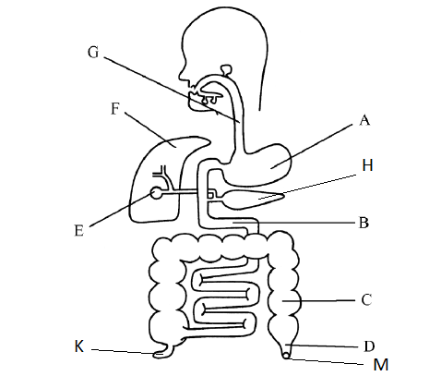
Q1 State the names of the following parts of the digestive system.
(i) A
(ii) B
(iii) C
(iv) E
(v) F
(vi) G
(vii) K
(A/M)

Q2 Give the letter of the structure that does each of the following functions.
Structure | Function
 | Stores bile
 | Absorbs food into the blood
 | Acts as a temporary store of food and digests some protein
 | Has no digestive function in humans
 | Produces digestive enzymes such as lipase and also makes insulin
 | A temporary storage location for faeces
(A/M)

Q3. A food company carries out laboratory tests on some of its products. The results are recorded below. Fill in the gaps to complete the report.
Product | Food type being tested | Chemicals added | Positive result
(i)Orange |  | Benedict’s solution
(ii)Rice |  |  | A blue/black colour
(iii)Sausage | Protein
(A/M)
Q4. Explain in detail (discuss) why we need to eat minerals and vitamins such as vitamin C.

A/M/E
Q5 Use named examples to discuss the difference between chemical and physical digestion.

A/M/E
Q6
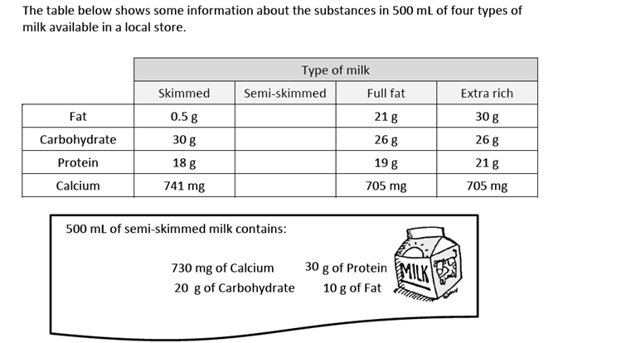
(a) Add the information about semi-skimmed milk to the table above
(b) Which type of milk contains the least protein?
(c) How much protein is found in 500mL of full fat milk?
(d) Which milk contains 60g of fat per litre?
A/M
(e) Which milk would you recommend for a person trying to lose weight and why?

A/M

Sound & Vision
Name: _________________________ Form Class: ______

Question 1
a) Label the parts of the eye on the diagram below.
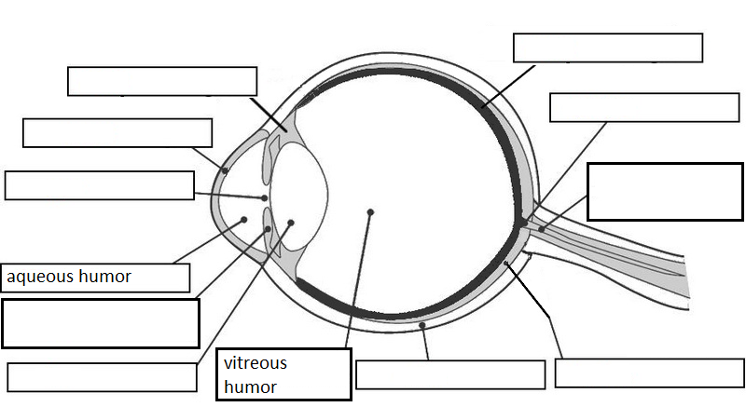A/M
b) Choose three parts and give their function

A/M/E
c) Choose one part and explain the consequences if this part does not function properly.

A/M

A/M
Question 3: Complete the diagram to show what will happen to three parallel light rays when they strike a concave lens.
A/M
Q4

A/M/E

Q5a) Complete the diagram of the ear below by placing the correct label on the lines linked to the structure. The hammer has been done for you

Label List:
Anvil | Cochlea | Eardrum
Eustachian tube | Nerves | Outer ear canal
Pinna | Semi-circular canals | Stirrup
A/M
A/M
A/M

Q6: Boats can use sound to work out where fish are. The speed of sound in sea water is 1500 ms⁻¹. A ship in the middle of the Pacific found it took 4 seconds for a sound made at the surface to bounce back from the seafloor. Show some working.
a: How far did the sound travel in 4 s? ___________________________________
b: How deep was the water at this point? _________________________________
A/M
Q7: Light is made up of seven different colours. Explain why we see white paper as being white.

A/M
Q8: Fill in the colours of the rainbow in their correct positions.
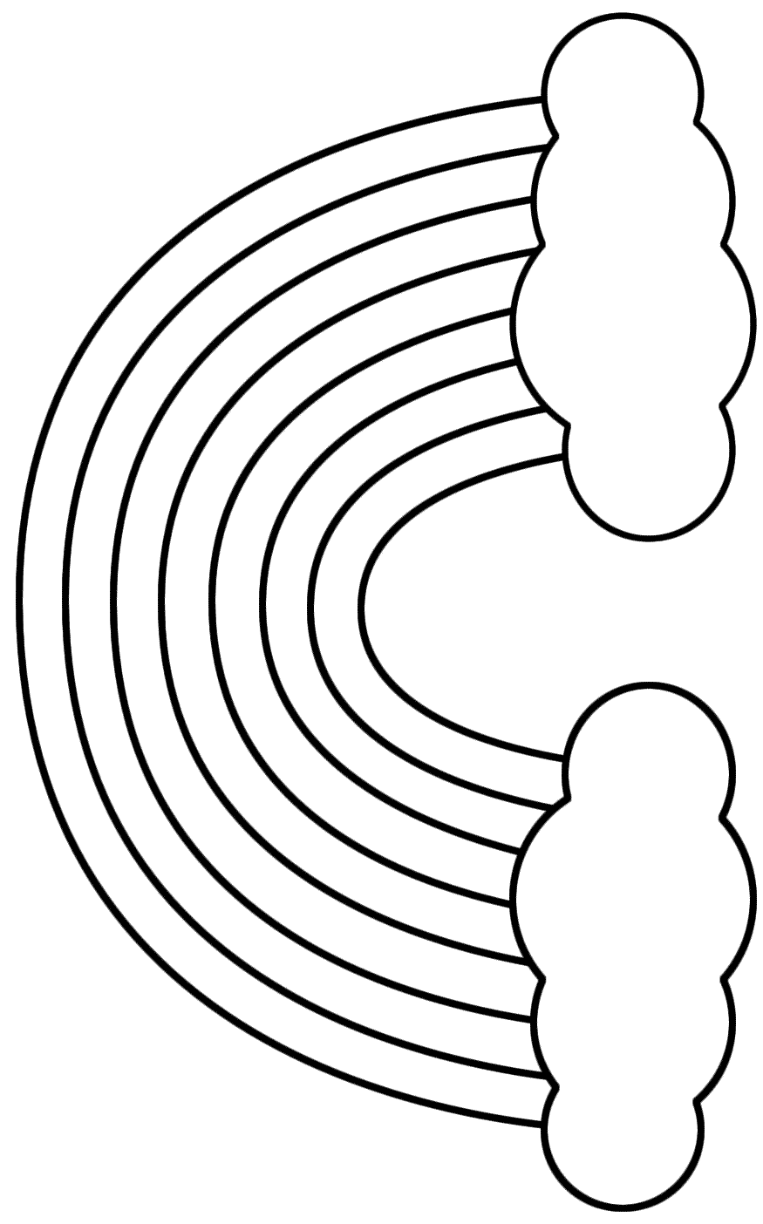
A

I’m on the move!
Name: _________________________ Form Class: ______

Q1: Complete the following sentence.
A force can be a _____________ or a ______________. The unit for force is the _______________, which has the symbol ______ . A force can change an object’s __________, __________ or ___________________, or a combination of all three.
(A/M)
Q2: Based on the statements you have made in question 1, write a few sentences that justify the statement “gravity is a force”.

(A/M/E)
Q3: The following table has data missing. Using the information it already contains and your understanding of the difference between mass and weight, complete the table. Don’t forget the units for the column headings.
Object | Mass ( ____ ) | Weight ( ___ )
Cat |  | 65
Bike |  | 250
Truck and trailer | 7500
Spoon | .045

(A/M)
Q4: What type of energy do the following objects mainly possess?
- An unlit birthday candle
- A flying bird
- A stretched spring
- A diver about to jump
- A ringing bell
- A working gas cooker
(A/M)
Q5 Complete energy flow diagrams/equations for the following.
- A working Bunsen burner

A/M
- A diver jumping and then falling into water

A/M
- A computer game being played on an iPod (not plugged in to wall)

A/M
E
Q6: If the average speed of an object can be calculated using the formula:
speed = distance/time
Calculate the average speed of the following in metres per second (ms⁻¹). (2 decimal places only. Show working)
- A horse takes 120 seconds to cover 600 metres.

(A/M)
- A student runs the 21,000 metre half marathon race in 90 minutes.

(A/M)
c) If a Bugatti Veyron has a speed of 275 km h⁻¹, how fast is it going in metres per second (show all working).

A/M
E
Q7
- Label the forces P and Q (on the diagram)
A/M
Q8 Describe, with reasons her motion.

A/M
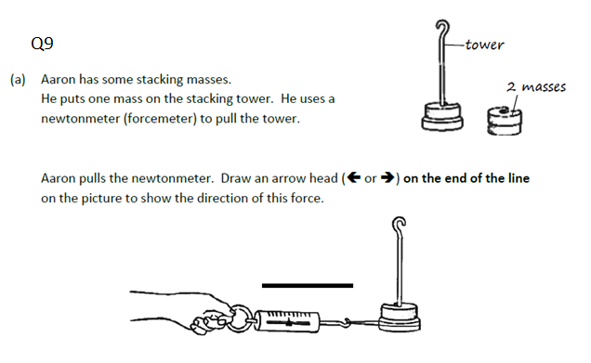
A
A/M

My Chemical World
Name: _________________________ Form Class: ______

Question 1
Tea bag | Hot water
James is making a cup of tea. Complete the paragraph below by filling in each gap with the correct word from the list. Not all words in the list will be used.

melts | evaporates | centrifuge | dissolves | diffuses | saturated
solute | solvent | solution | dissolving | filter | solubility

The cup of tea is a (i) ___________________ made by the tea (ii) ________________ out of the tea leaves into the hot water. The water is the (iii) _________________ which (iv) _________________ the tea. The tea bag acts as a (v) _________________ to separate the tea leaves from the water. The water gradually becomes darker as the tea (vi)_______________ through the liquid. People do not generally make tea using cold water because the (vii)________________ of the tea is low in cold water. A cup of tea that contains as much tea as the water can hold would be said to be (viii)________________________.
A/M
Q2 The three diagramsbelow showwater in three states of matter.

- Label the correct digram for ice, water vapour and liquid water
A
A
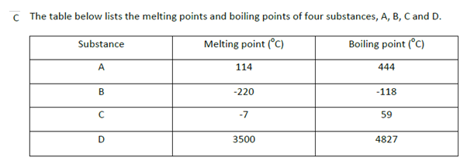
(i) Explain how you know that substance C is a liquid at room temperature and is not any other state.
A/M
(ii) Which substance is liquid over the largest temperature range? Show working.
A/M

Question 3 Some gas cooker fuel is sold in canisters that contain a compressed gas such as propane or butane.  Discuss in terms of the particle theory of matter why liquid and solid fuel (such as oil and coal) cannot be compressed but gas fuel can be. | 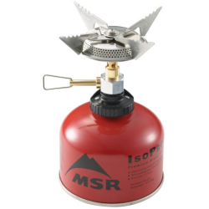

A/M/E
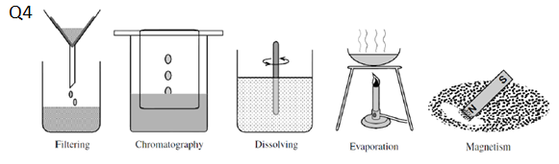
(a) Which of the methods above would be most suitable for separating the following mixtures? You may need more than one method in your answer.
(i) a mixture of sand and salt
(ii) seawater (only the salt needs to be kept)
(iii) a mixture of iron filings and sand
A/M

Q5: In the space below draw a labeled diagram to show how you would react magnesium dioxide powder (MgO₂) with hydrogen peroxide (H₂O₂) and collect the gas that is produced.

(A/M/E)
Q6: What was the gas produced by this reaction and how would you go about testing to show that this was the gas that is produced?

(A/M)
Only do this if you have completed AND CHECKED your exam (this isn’t marked)

